Support Tools

Traits and Notes 2
Adding Traits 2
Adding Notes 2
Phrases 3
Adding, renaming and deleting phrases 3
Accessing lists of phrases 3
Trait, Note, Reference Link, Multimedia and Keyword Types 3
Automatic Number Generation window 4
Working with literature 5
Searching 5
Managing items 5
Favorites 5
Entering a reference code 6
Reference details 6
Journal Article 7
Journal Section 7
Book 7
Book Section 8
Internet URL 8
Miscellaneous 8
Journal Manager 8
Adding, editing and deleting journals 9
Journal details 9
Multimedia Manager 9
Searching 9
Managing items 10
Multimedia details 10
User Manager 11
Adding new users 11
Setting general permissions 11
Setting taxon permissions 12
Passwords 12

Traits and Notes
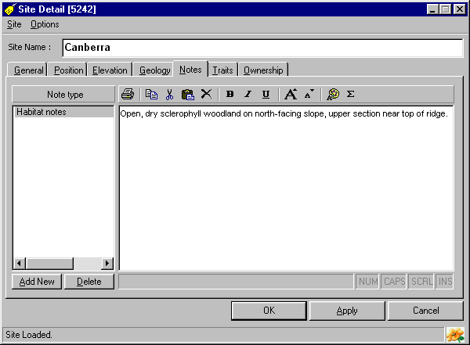
BioLink manages information that is common across most taxonomic groups and scientific disciplines. However, specific taxa and disciplines will need to manage additional information that is specific to their taxa or studies. This information includes such things as characteristics of specimens (for example colours, sizes), details of storage locations or methods (for example location on microscope slides) and environmental characteristics such as nest sites, soil types or weather conditions. The list of these sorts of data elements is almost limitless.
To address this problem, BioLink allows Traits and Notes to be attached to most items within the database. Traits are characteristics that are best described using a single word, value or short phrase. Notes are text-based, can be of any length and can include font formatting (bold, italics, underlining, font type, size and colour). Traits and Notes are added as required and individual items can have as many Traits and Notes as required. In essence, Traits and Notes allow users to add new fields to their databases when and where required.

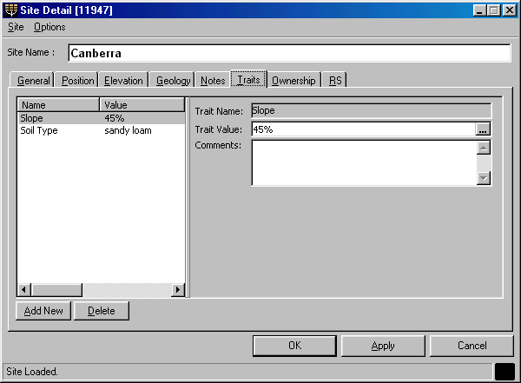
Adding Traits
Traits are added using the Site Details, Site Visit Details and Material windows. Open these windows using the Site Explorer or Rapid Data Entry window. Once open, select the Traits tab. Pressing the Add New button will open a window with a list of titles of previously used Traits. Select a title for the new Trait or create a new title using the Add New button near the bottom of the list. Press the OK button on the Trait window to create the new Trait and return to the Details window. The value for this Trait can now be entered in the Trait Value field on the right side of the Traits tab. A comment concerning this Trait can also be included.
To save the new Trait, press the OK or Apply button. To remove a Trait, select the Trait and press the Delete button.

Adding Notes
Notes are added using the Site Details, Site Visit Details and Material Details windows. Open these windows using the Site Explorer or Rapid Data Entry window. Once open, select the Notes tab. Pressing the Add New button will open a window with a list of titles of previously used Notes. Select a title for the new Note or create a new title using the Add New button near the bottom of the list. Press the OK button on the Phrase window to create the new Note and return to the Details window. The text for this Note can now be entered in the right side of the Notes tab. To format text, including bold, italics, underlining, font size and font colour, select the text and use the buttons on the toolbar. Symbols can be entered by pressing the Sigma button. The Note text can be printed and copied or cut to the clipboard using the toolbar, and the contents of the Clipboard can be added to a Note using the Paste button.
To save the new Note, press the OK or Apply button. To remove a Note, select the Note and press the Delete button.

Phrases
The Phrase Manager provides centralised control of the phrases used to fill many of the items within BioLink. This means that controlled vocabularies and authoritative lists can be prepared to increase data consistency and reduce errors when entering data. It also speeds data entry and editing.
To open the Phrase Manager select the Phrases command from the Admin & Tools button on the main BioLink toolbar. The Phrase Manager contains a list of phrase categories on the left with their corresponding phrases on the right. Phrase categories which are part of core BioLink (that is, fields which are ‘hard coded’ into BioLink) are displayed in green while categories which are based on Traits are shown in red. Phrases with a red icon (to their left) are managed through the Detail windows and should be ignored.

Adding, renaming and deleting phrases
To add a new phrase to a category, select the category of interest followed by the Add Phrase command from the Phrases command of the Edit menu. Replace the default <New Phrase> text with the name of the phrase and press the Enter key. To rename an existing phrase, select the Rename Phrase command from this same menu, and to delete a phrase select it in the list and select the Delete Phrase command. Pressing the OK or Apply buttons will save changes to the database while the Cancel button will close the window without saving changes.

Accessing lists of phrases
Many of the fields on the Rapid Data Entry and Detail windows have an Ellipsis button (with the three dots) to their right. Clicking this button or pressing Ctrl+Enter will open the Phrase window and display the phrases appropriate for the field. Double clicking on an entry in the Phrase window or clicking the OK button will transfer the selected phrase to the field used to close the window.

Trait, Note, Reference Link, Multimedia and Keyword Types
The Trait Types, Note Types, Reference Link Types, Multimedia Types and Keyword Types windows are used to enter and manage the types or categories of these items. To open these windows select the appropriate command from the Admin & Tools button on the main BioLink toolbar.
Each of these windows has a picklist of the BioLink items associated with the selected type near the top. Select an item from this list to display the current types used by that item. To add a new type, press the Add New button. Replace the default <New> text with the name of the type and press the Enter key. To rename an existing type, select it in the list, click the right mouse button and select the Rename command. To delete a type select it in the list, click the right mouse button and select the Delete command. Pressing the OK or Apply buttons will save changes to the database while the Cancel button will close the window without saving changes.
WARNING: Deleting a type will remove ALL associated records for that type throughout the database. This means that any number of records will be deleted WITHOUT ADDITIONAL WARNING, so BE CAREFUL WHEN DELETING TYPES!

Automatic Number Generation window
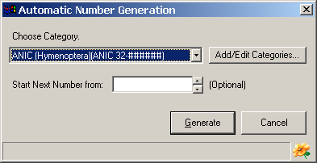
The Automatic Number Generation window is used to manage sequences of numbers. These sequences are commonly used for such things as loan numbers and accession numbers. To open this window press the Ellipsis button to the right of a field which supports the use of automatic numbers. Once open select the number category from the list box and press the Generate button. The next available number in the sequence will be transferred to the field.
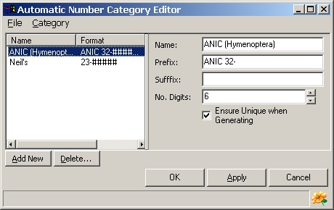
To create a new series or category of numbers press the Add/Edit Categories button. This will open the Automatic Number Category Editor. Any number of categories can be created. To add a new category press the Add New button near the bottom left of the window. The details for this category can then be entered in the fields on the right of the window. To edit an existing category, select the required category from the list and edit its details on the right. To delete a previously entered category, select it in the list and press the Delete button.
The following details can be recorded for each category.
Name: The name of the category.
Prefix: A set of characters to be appended before the number.
Suffix: A set of characters to be appended to the end of the number.
Number of Digits: The number of digits in the number. If the number contains fewer than this number of digits zero’s will be added before the number to increase the total number to this minimum.

For example, to generate a series of numbers such as:
ANIC:0001
ANIC:0002
enter the following:
Prefix: ANIC:
Suffix: <leave blank>
Number of Digits: 4

To create numbers such as
32-0000001(Birds)
32-0000002(Birds)
enter the following:
Prefix: 32-
Suffix: (Birds)
Number of Digits: 7

Working with literature
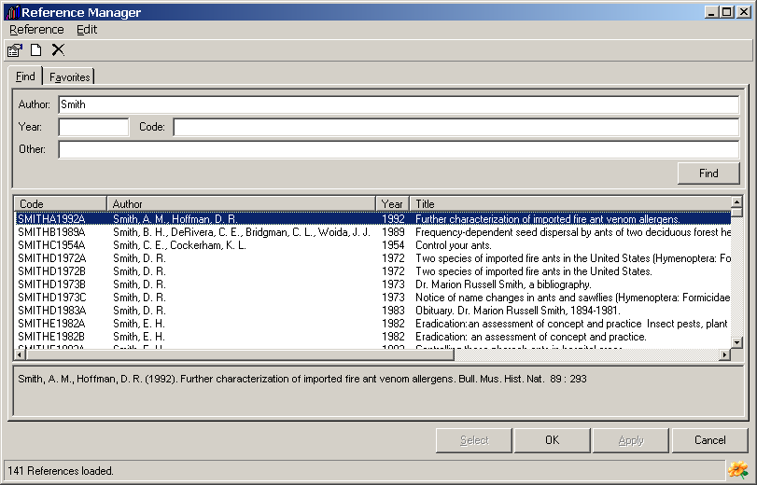
The Reference Manager is used to enter and manage literature references. To open this window select the Reference Manager command from the Admin & Tools button on the main BioLink toolbar.

Searching
To search for a reference or set of references enter information in the fields near the top of the Find tab. Searches can include author(s) name(s), year of publication, Reference Code or a text string found in the citation (including in the title and publishing details). Enter search terms as required and press the Find button or the Enter key. A list of references matching the request will be displayed in the list near the bottom of the window. A full citation for the selected reference is displayed along the bottom of the window.

Managing items
To add a new reference, select the Add Reference command from the Edit menu. This will open the New Reference window where details for the reference can be added (see Reference Details below). To edit details of a previously entered reference select it in the list and select the Edit Reference command from the Edit menu. To delete a reference, select it and choose the Delete command from the Edit menu. To combine references, using drag and drop, dragging the reference to be removed and dropping it onto the reference it is to be combined with. The dragged reference will be deleted and references to it changed to refer to the dropped reference.

Favorites
Favorites are used to manage commonly used references. To transfer a reference to Favorites, select it in the list on the Find tab and select the Add Reference to Favorites command from the Edit menu. The reference can be added to either the User Specific favorites, which are available only to the person creating them, or to Global Favorites, which are all users of a database. To use these favorites, click the Favorites tab. Items transferred to Favorites will be displayed under User Favorites and Global Favorites.

Entering a reference code
Within BioLink references are identified by a unique code. This code is entered or created when a reference is initially entered into BioLink. It can consist of any combination of letters and/or numbers with a maximum length of 50 characters, the only restriction being that it must be unique within the database. This code is used to identify a reference throughout BioLink.
This reference code can be entered into a BioLink Reference field in one of two ways. It can be typed or copied directly into a Reference field or it can be transferred from the Reference Explorer using the Select button or Drag and Drop. If an incorrect code is entered BioLink will generate an error message. To open the Reference Manager, press the ellipsis button to the right of the Reference field. To view details for a previously entered reference press the magnifying glass button.

Reference details
Information concerning the details of individual references is stored in the Reference Detail window. To open this window, use the Reference Manager to locate a reference. Once located either double click the reference in the list or selected it, click the right mouse button or open the Edit menu and select the Edit Reference command. This will open the Reference Detail window filled with information for the selected reference.
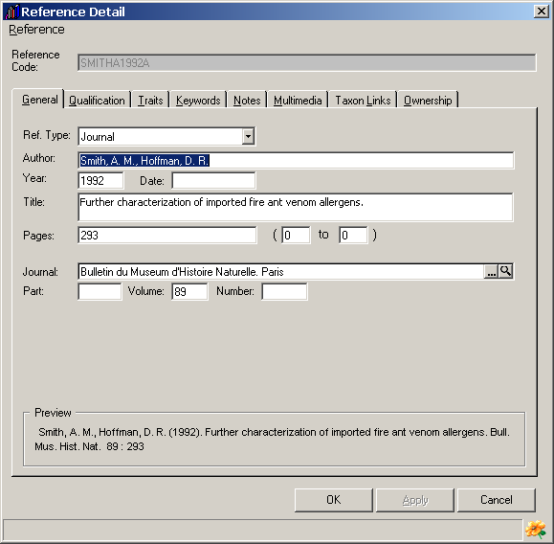
BioLink supports six reference types. These include the following:
- Journal Article: An article published in a journal. This is the most common reference type for scientific publications.
- Journal Section: A publication that is embedded in a journal article published by another author. This is commonly used for species attributed to an author who is not the author of the main article.
- Book: A complete book.
- Book Section: A book section or chapter.
- Internet URL: A Web or URL-based publication.
- Miscellaneous: Assorted publications that do not fit the above categories. This is a ‘catch-all’ for things such as pamphlets, reports, unpublished theses/dissertations and similar publications.
Details of the items stored for each reference type are as follows. To select a specific reference type, use the Ref. Type picklist near the top of the General tab of the Reference Detail window.

Journal Article
Author: The author(s) of the article.
Year: The year of publication.
Date: The date of publication.
Title: The title of the article.
Pages and (… to …): The page numbers and starting and ending page numbers (range) of the article. The page range is used when validating citations where specific pages are referred to.
Journal: The name of the journal where the article is published. Journals are entered and managed using the Journal Manager.
Part: The journal part or series number.
Volume: The journal volume number.
Number: The number of the journal volume.

Journal Section
Author of section: The author(s) of the section.
Year: The year of publication.
Date: The date of publication.
Title of section: The title of the section.
Pages and (… to …) of section: The page numbers and starting and ending page numbers (range) of the section. The page range is used when validating citations where specific pages are referred to.
Author of article: The author(s) of the article.
Title of article: The title of the article.
Journal: The name of the journal where the section is published. Journals are entered and managed using the Journal Manager.
Part: The journal part or series number.
Volume: The journal volume number.
Number: The number of the journal volume.
Pages of article: The page numbers of the article.

Book
Author: The author(s) of the book.
Year: The year of publication.
Date: The date of publication.
Title: The title of the book.
Pages and (… to …): The page numbers and starting and ending page numbers (range) of the book. The page range is used when validating citations where specific pages are referred to.
Publisher: The name of the publisher.
Place: The place of publication.
Edition: The edition of the book.
Volume: The volume number of the book.
ISBN: The ISBN (International Standard Book Number) for the book.

Book Section
Author of section: The author(s) of the section.
Year: The year of publication.
Date: The date of publication.
Title of section: The title of the section.
Pages and (… to …) of section: The page numbers and starting and ending page numbers (range) of the section. The page range is used when validating citations where specific pages are referred to.
Author of book: The author(s) of the book.
Title of book: The title of the book.
Publisher: The name of the publisher.
Place: The place of publication.
Edition: The edition of the book.
Volume: The volume number of the book.
ISBN: The ISBN (International Standard Book Number) for the book.
Pages of book: The page numbers of the book.

Internet URL
Author: The author(s) of the article.
Year: The year of publication.
Date: The date of publication.
Title: The title of the article.
Pages and (… to …): The page numbers and starting and ending page numbers (range) of the article. The page range is used when validating citations where specific pages are referred to. This may not apply to all URL-based resources.
URL: The URL of the article.

Miscellaneous
Author: The author(s) of the publication.
Year: The year of publication.
Date: The date of publication.
Title: The title of the publication.
Pages and (… to …): The page numbers and starting and ending page numbers (range) of the publication. The page range is used when validating citations where specific pages are referred to.
Source: The source of the publication.

Journal Manager
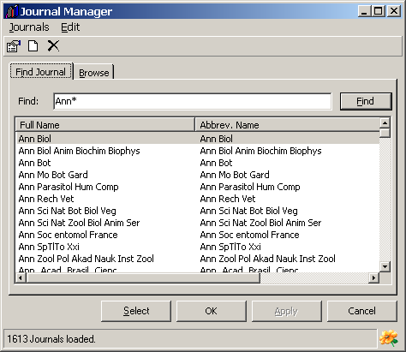
The Journal Manager is used to add, update and delete journals. To open this Manager, select the Journals command under the Admin & Tools button on the main BioLink toolbar.
The Journal Manager has two tabs. The Find Journal tab is used to locate journals that contain a text string. To use this feature, enter the name (or part thereof, including the wildcard character *) and press the Find button. A list of journals meeting the request will be returned in the list in the lower section of the window. To transfer a journal to a reference, select the required journal in the list and press the Select button or use drag and drop to move the journal to the Reference Detail window. (The Select button will only be active if the Journal Manager was opened from the Reference Detail window.)
The second tab on this window, Browse, presents a complete list of journals held in the database grouped alphabetically. To move through the list, press the appropriate tab on the right of the window and scroll through the list to locate the required journal.

Adding, editing and deleting journals
To add a new journal, select the Add New Journal command from the Edit menu. This will open the Journal Detail window where details for the journal can be added. To edit the details for a journal locate it as outlined above and select the Edit Journal Details command. This will open the Journal Detail window loaded with information for the selected journal. To delete a journal, select it and use the Delete Journal command. Only journals that have not been used for an article can be deleted.

Journal details
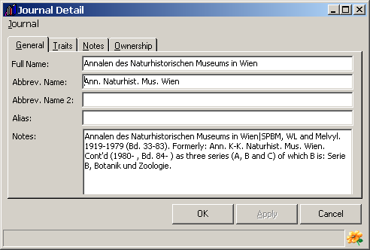
The Journal Detail window contains details for each journal. To open this window select a journal using the Journal Manager followed by the Edit Journal Details command on the Edit menu.
The following items can be stored for each journal:
Full Name: The full name of the journal.
Abbreviated Name: The preferred abbreviation for the journal.
Abbreviated Name 2: An alternate abbreviation for the journal.
Alias: An alias or short name for the journal used during searching. For example, the journal South African Journal of Natural History may have an alias of SAJNA.
Notes: Assorted notes on the journal.
User-defined Traits and Notes.

Multimedia Manager
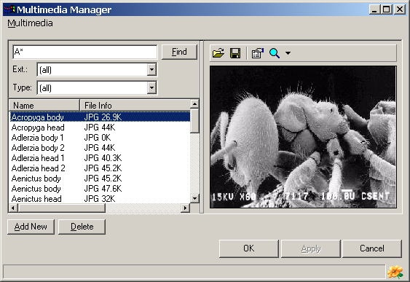
The Multimedia Manager is used to manage all multimedia items stored in a database. A search facility is provided as well as access to details concerning individual items (see Multimedia Details below).

Searching
To search for an item, enter a search term in the upper left field of the window. The search will look in the item name field as well as keywords (stored in the Multimedia Details window). To restrict the search to files with a specific extension select the required extension from the Ext. picklist. To restrict the search to items of a specific type select the required type from the Type picklist. Once these criteria are entered press the Find button or the Enter key to run the search. A list of making multimedia items will be returned in the list on the left side of the window.

Managing items
To add a new multimedia file, press the Add New button near the lower left corner of the window. This will open a File Open dialog box where the required file can be selected. Alternately, a file can be moved from the Windows Explorer or My Computer using Drag and Drop. Locate the desired file in the Windows Explorer or using My Computer and drag it onto either the Multimedia list (on the left side of the Multimedia window). The Preview window, on the right side of the window, will display a preview of most graphics files. If the selected file cannot be viewed a message will be displayed. To view these non-displayable files press the Magnifying Glass button on the toolbar. This will open the application associated with the file and automatically load the file. If no application is associated with the selected file a dialog will open asking the name of the application to use to view the file.
Details for the file can be entered by opening the Properties window. To open this window, select an item in the list, and click the Properties button on the toolbar (the third from the left). The details available are listed below. To delete a file, select it and press the Delete button. Once changes have been made press the OK button to save changes and close the Taxon Details window or the Apply button to save changes and leave the window open. Pressing the Cancel button will close the window without saving changes.
To replace an existing file with a new one select the old file in the list and press the first toolbar button (the button with the file folder icon). A File Open dialog box will be displayed allowing selection of the replacement file. To save an existing file to disk, select it in the list and press the second toolbar button (the button with a disk icon). A Save As dialog box will open where a new file name and path can be entered.

Multimedia details
A series of information can be stored for each multimedia item. The following items concerning multimedia can be stored.
ID Number: A number assigned to this file.
Artist/Creator: The name of the person who created the file.
Owner: The owner of the file.
Creation Date: The date the file was created.
Copyright: A copyright notice associated with the file.
Traits: User-defined traits for the file.
Keywords: Keywords associated with the file.

User Manager
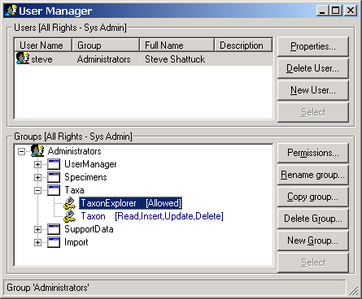
The User Manager can be used to control access to items within BioLink. This includes whether or not access is granted, and if granted, whether information can be read, inserted, updated and/or deleted. Permissions are set for groups of users, and an individual user can belong to only one group. To open the User Manager select the User Manager command under the User Manager button on the main BioLink toolbar.

Adding new users
Only ‘sa’ can add users to a database. This is because to add new users one must have administrator permissions to the SQLServer database. This can pose a security threat to BioLink databases, other databases on the same computer and to the computer itself. To minimize this potential security problem only the system administrator can add users. This means that you must log on as ‘sa’ before adding new users.
To add a new user to a BioLink database, click the New User button on the right side of the upper panel of the window. This will open the User Details window. The following items should be entered.
Username: The username of the new user. This will be the name used when logging into a BioLink database
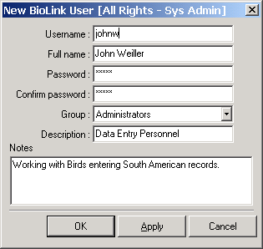
Full Name: The full name of the user.
Password: A password for the user.
Confirm Password: The password repeated. This must be the same as the above password and is used to ensure the intended password has been entered.
Group: The group the user belongs to. This is selected from a picklist. See below for details on creating groups.
Description: A short description of the user.
Notes: Assorted notes about the user.
Once these details have been entered press the OK or Apply buttons to save changes or the Cancel button to abandon this new user.

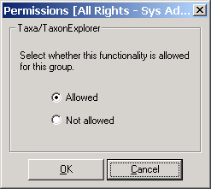
Setting general permissions
Permissions are set individually for each group of users. To change permissions select an existing group by selecting it in the list or create a new group by pressing the New Group button and entering its name. Open the details for the selected group by double clicking its name. This will display a list of categories for which permissions can be set, including User Manager, Specimens, Taxa, Support Data and Import. Expand the category of interest by double clicking its name. This will display a set of items whose permissions can be set. To control access to an item, select it and press the Permissions button. This will open the Permissions window. This window will contain one of two sets of options for controlling access.
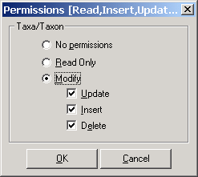
The first set of options include the following:
Allowed: Grants access to the item.
Not Allowed: Denies access to the item. If this is selected none of the users in the selected Group will be allowed access to this item.
The second set of options include the following.
No Permissions: When selected the item can be accessed but it cannot be modified or deleted. Additionally, its details (if any) are not available.
Read Only: When selected, items and their details are available but they cannot be modified or deleted.
Modify: This option allows partial to complete access to the item and its information. There are three sub-options: Update: Allows modification of existing information, Insert allows the addition of new records and information and Delete: Allows the removal of items and information.
Once the required options have been set press the OK button to save changes or the Cancel button to abandon them.

Setting taxon permissions
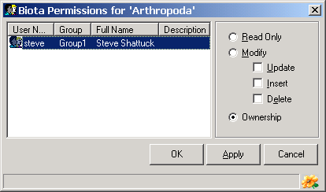
The Taxon Permissions window is used to set access privileges for individual taxa within the Taxon Explorer. These permissions are only available if access to the Explorer is first granted using the User Manager. Setting permissions for individual taxa is important when different users of a BioLink database are responsible for maintaining different taxonomic groups. Access privileges can be set to Read Only or Modify and the Ownership can also be set. To set the level of access select the taxon of interest, open the Edit menu or click the right mouse button and select the Permissions command. This will open the Taxon Permissions window. This window provides a list of the current users of the database along with the access options. To set access privileges, select a user from the list and set the appropriate options.
The available options are as follows:
Read Only. When selected, the taxon (and all of its children) can be viewed but not changed or deleted.
Modify. This allows changes to made to the taxon (and its children). These changes can be set to Update (changing), Insert (adding new taxa) and Delete. When this option is selected the user cannot assign permissions to other users.
Ownership. When selected the user has full access to this taxon (and its children). This user can also give permissions to other users.
Once the required options have been set press the OK or Apply buttons to save changes or the Cancel button to close the window without saving.

Passwords
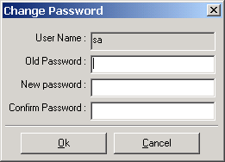
To change an existing password open the Change Password window by selecting the Change Password command from under the User Manager button on the main BioLink toolbar. The window will open with the name of the currently logged in user. Enter the current password in the Old Password field and the new password in both the New Password and Confirm Password fields. Press the OK button to save the new password or the Cancel button to return to the old password. If the current password entered is incorrect or the same password is not entered in both the New Password and Confirm Password fields an error message will be displayed and the new password will not take effect.

